Optimizing Supply Chain Efficiency for McTrump’s Fast-Food Distribution Network in New York

**Team members:**

Shalvi Sudhir Deshmukh - xn7935

**Summary**

McTrump’s Co., a renowned fast-food giant headquartered in New York City, is strategically planning to enhance its supply chain operations by establishing a centralized distribution center (DC) to serve seven outlets across New York State. The primary objective is to minimize shipping distances, thereby improving operational efficiency and cost-effectiveness.

McTrump’s value proposition is to provide customers with fresh food, at any point and at an affordable price. This is why it becomes important to find an apt place to open the distribution center which caters to seven outlets in NewYork in an optimized way, both cost and time-wise.

The team focused on minimizing shipping distances and leveraged advanced optimization techniques and mathematical modeling. We successfully developed an optimized model that meets all constraints while minimizing total shipping distances by employing Microsoft Excel's Solver and SolverTable add-in. Sensitivity analysis provided valuable insights into the impact of various factors on the model's performance, allowing for informed decision-making.

While the optimized solution demonstrates promising results, its practical implementation at scale may require additional resources and infrastructure. Nonetheless, the project highlights McTrump's potential strategic advantages in the competitive fast-food industry landscape. With a streamlined supply chain and optimized distribution network, McTrump is poised to enhance customer satisfaction by providing fresh food, reduce operational costs by planning to build a distribution center at the optimal location, and maintain its competitive edge in the market.

**Introduction**

**Company**

McTrump's, the renowned fast-food giant headquartered in the bustling metropolis of New York City, has garnered global acclaim for its diverse menu offerings, serving millions of customers daily across its expansive network of restaurants worldwide. At the core of McTrump's operational efficiency lies its meticulously designed distribution network, which facilitates the seamless transportation of raw materials, ingredients, and finished products from suppliers to restaurants. By prioritizing cost-effective shipping solutions, McTrump's not only ensures timely deliveries but also minimizes overhead costs, thus maintaining its profitability and competitive edge in the fast-food industry.

**Problem**

The company is strategizing the establishment of a distribution center (DC) to streamline the transportation of fresh products to seven designated fast-food outlets in the vicinity. The primary aim is to minimize the total shipping distances from the distribution center (DC) to the seven specified locations within New York State. By minimizing these distances, McTrump's Co. can enhance the efficiency of its supply chain operations.

In this scenario, the latitude (xdc) and longitude (ydc) coordinates of the distribution center (DC) within New York State are crucial parameters for optimizing the minimum total shipping distances.

The geographic limitations mandate that the distribution center (DC) must be strategically positioned within the defined boundaries set by the East River and the Hudson River. These limitations are expressed as inequalities for both latitude and longitude coordinates, ensuring the distribution center's placement within the specified geographical area. Determining the coordinates of these rivers and the intersection points become crucial to effectively decide the ideal location for the distribution center.

**Table 1** displays the Longitude and Latitude coordinates of the seven outlets alongside the estimated annual shipments for each store.

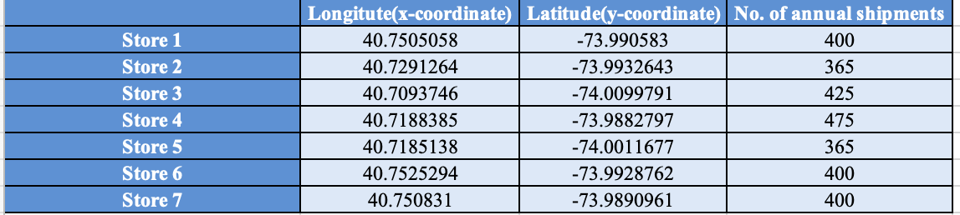

From the table, we can gather that Stores 1, 3, 4, 6 and 7 have more than 365 shipments annually, which might mean that these locations have more than one shipment delivery in a day.

**Proposed Solution**

Employing advanced non-linear optimization algorithms and comprehensive geographic analysis, we will determine the optimal latitude (xdc) and longitude (ydc) coordinates for the distribution center within New York State. The proposed solution is optimizing McTrump's supply chain network, strategically minimizing the distance traveled to deliver goods from the distribution center to the designated fast-food outlets. This approach enhances operational efficiency, generates significant cost savings, and elevates service standards.

**Main Chapter**

**Data collection**

Our data collection process commenced by pinpointing the locations within New York City of the seven McTrump stores. This data will then be used for the model formulation on MS Excel.

**Figure 1** illustrates the geographical locations of the seven outlets 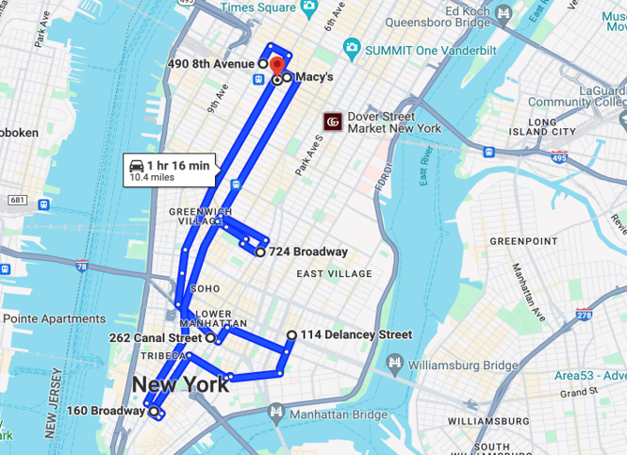

Additionally, we gathered the total number of annual shipments for each store. The graph below illustrates this data, with Store 4 recording the highest number of shipments at 475, while Store 2 and Store 5 have the lowest, each with 365 shipments. It would be ideal if the distribution center

is closer to the stores which have more than 365 shipments annually. This would help in minimizing the distance between the distribution center and the stores.

**Figure 2** depicts a bar graph comparing the number of shipments across different stores.

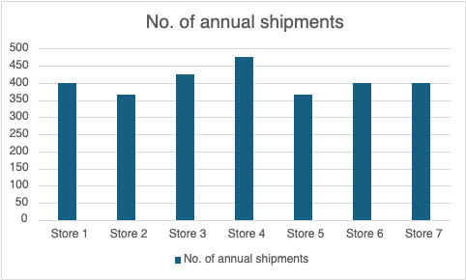

Furthermore, we gathered approximate coordinates for the East River and Hudson River. This also included identifying a specific area on the map where these two rivers merge. Hence, to accommodate this, we introduced an additional constraint line labeled "River Connect" which signifies the convergence point of these two rivers (Refer to Figure 3).

**Table 2** represents the start and end points of East and Hudson rivers and their intersection points

​​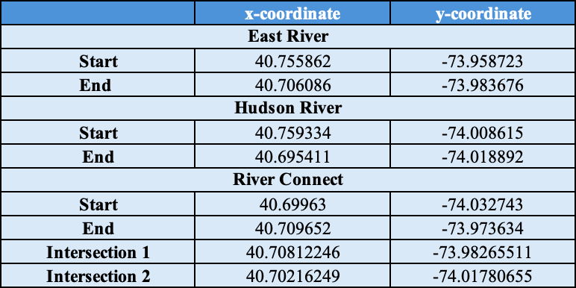

The additional points labeled as Intersection 1 and Intersection 2 serve a vital purpose in our model formulation process. These points denote the meeting points of the East River with the River Connect and the Hudson River with the River Connect, respectively. Accurately pinpointing these intersections allows us to establish constraints that align our model with the geographic features of the area.

**Figure 3** illustrates the coordinate system depiction of the map

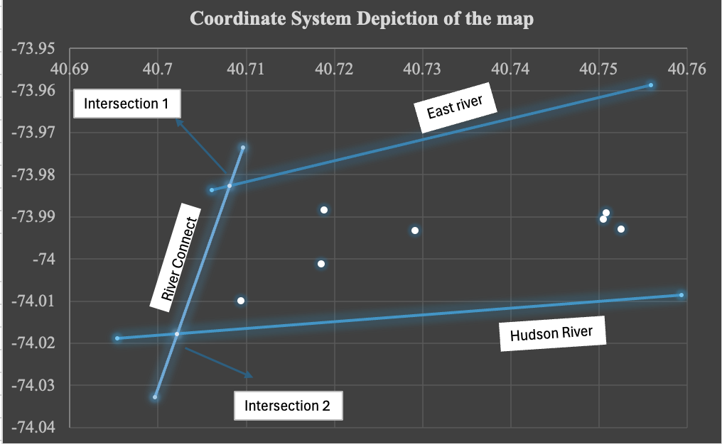

**Data Analysis**

The data analysis process comprised several steps. Initially, the input coordinates for the seven stores and the rivers were provided in longitude and latitude format. Given the inherent complexities associated with working directly with geographic coordinates, including variations in scale and units, we employed normalization techniques. These techniques enabled us to standardize the data, making it more conducive for analysis.

**Table 3** gives an overview of the standardization:

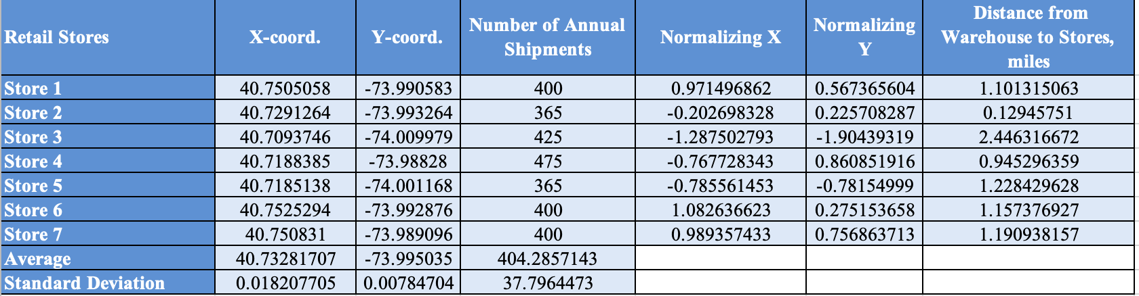

Mathematical formula used: (coordinate - mean) / std dev

Where, coordinate would be X or Y coordinate values

Excel formula/function: STANDARDIZE(coordinate value, mean, sd)

Where, coordinate is X-coord or Y-coord values

**Figure 4** illustrates the coordinate system depiction of the map (Refer Figure 1) after normalization

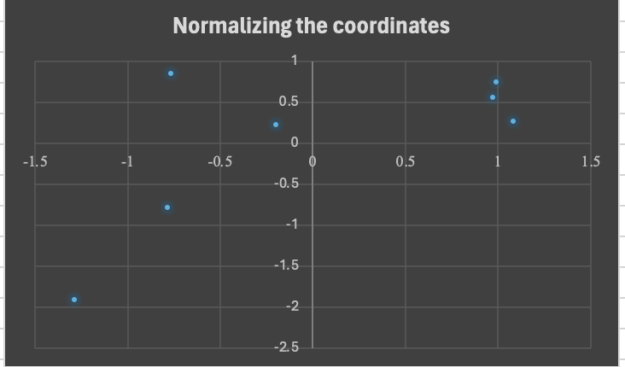

Furthermore, we leveraged Python programming to compute the intersection points, streamlining the evaluation process for enhanced efficiency and accuracy.

**Figure 5** presents a snippet of the Python program utilized to compute one of the intersection points.

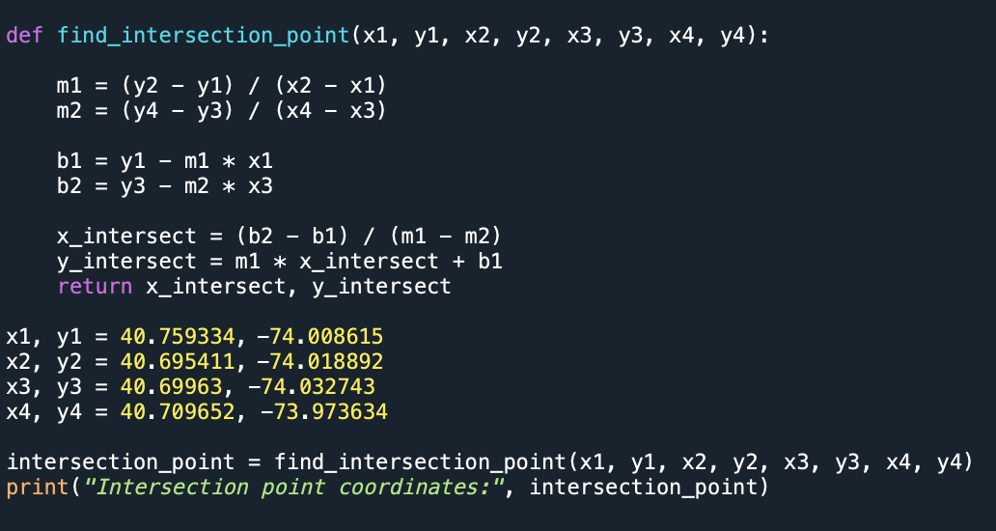

**Requirements Gathering**

The requirement-gathering process for our optimization project involved a detailed examination of the data and parameters necessary for formulating a tailored model to minimize the total shipping distances from the distribution center (DC) to the seven specified locations within New York State. We began by collecting comprehensive data, including coordinates for the seven stores, annual shipment volumes for each store, and approximate coordinates for the East River and Hudson River. This data formed the foundation for our optimization model. Additionally, we identified intersection points between rivers and introduced constraint lines to ensure the model aligns seamlessly with the area's geographic features. Normalization techniques were then applied to standardize input coordinates, ensuring consistency and accuracy in our analysis. To compute intersection points efficiently, we utilized Python programming. This approach streamlined our analysis process, allowing for faster iteration and optimization of the model.

**Optimization Model**

Having covered the problem and background, we'll now delve into the specifics of our optimization model. This will involve discussing the decision variables, inputs, and objectives in detail to understand how the model will be structured and how it will help us achieve our goals.

**Decision Variables:**

xdc represents the x-coordinate of the distribution center (DC)

ydc represents the y-coordinate of the distribution center (DC)

**Inputs:**

*i* denotes the store index, where *i* = 1…7

xi represents the x-coordinate of store *i*

yi represents the y-coordinate of store *i*

*si* represents the projected number of annual shipments from the warehouse to store *i*

**Calculated Value:**

*di* represents the distance between the warehouse and store *i*, calculated using the Euclidean distance formula: 

**Objective function:** The objective is to minimize the total annual shipping distances, which is expressed as the sumproduct of the estimated number of annual shipments (​*si*) and the respective distances (*di*):

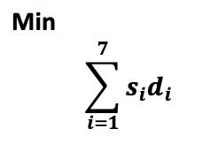

**Constraints:**

X-coordinate limits for distribution center (DC) location: xdc ≤ XU, xdc ≥ XL

Y-coordinate limits for distribution center (DC) location: ydc ≤ YU, ydc ≥ YL

Where XU and YU are the upper limits of the optimal solution and XL and YL are the lower limits of the optimal solution.

**Table 4** represents the constraints considered in the formulation of optimization model

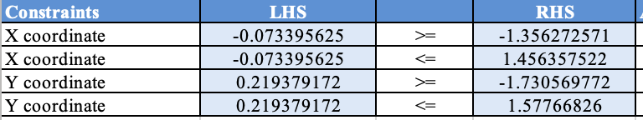

* Xdc ≥ -1.356272571 which means that the minimum allowable X-coordinate for the distribution center is set to -1.356272571, ensuring that the DC remains below the East River (Refer Figure 3)
* Xdc ≤ 1.456357522 which means that the maximum allowable X-coordinate is limited to 1.456357522, ensuring that the DC is positioned above the Hudson River (Refer Figure 3)
* Ydc ≥ -1.730569772 which means that the minimum allowable Y-coordinate is set to -1.730569772, ensuring that the distribution center lies to the right of the merging point of the East River and the Hudson River (Refer Figure 3)
* Ydc ≤ 1.57766826 The maximum allowable Y-coordinate is limited to 1.57766826, ensuring that the distribution center remains to the right of the merging point of the East River and the Hudson River (Refer Figure 3)

These constraints guarantee that the distribution center remains within the defined boundaries set by the East River and the Hudson River while optimizing shipping distances to the target stores.

With our model built, we proceeded to solve it using Excel Solver add-in. Employing the GRG Nonlinear function within Solver and using the minimum function, we aimed to obtain our optimized solution. We made sure to uncheck the non-negativity constraints as the coordinates of the distribution center could lie in the negative quadrant of the cartesian plane as well.

**Solution Results and Analysis**

**Table 5** depicts the optimal model that adheres to all imposed constraints 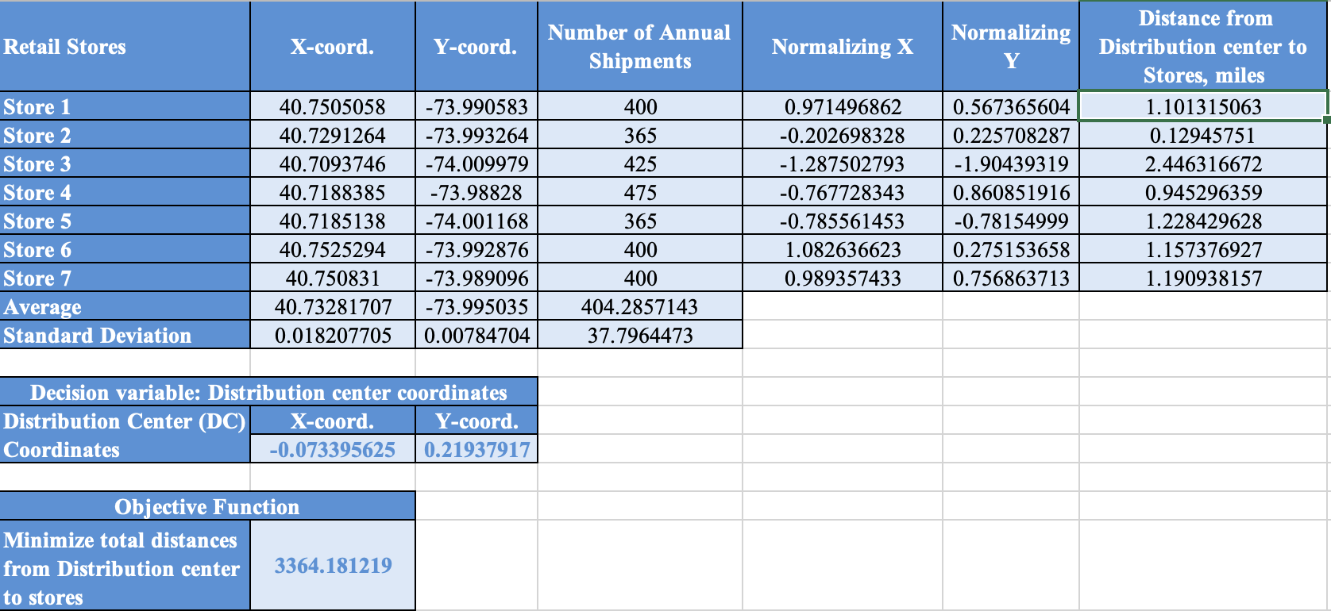

In the optimal solution, we have the normalized values of x = -0.073395625 and y = 0.219379172. The optimal solution for the distribution center coordinates, determined through the optimization model, is situated at longitude 40.73148071 and latitude -73.99331366. We denormalized it by using the same formula - (coordinate - mean) / std dev.

**Table 6** gives the actual coordinates of the optimal solution

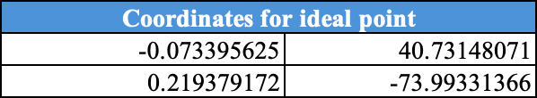

This solution effectively minimizes the total shipping distance from the distribution center to the stores, resulting in a total distance of 3,364.18 miles.

**Sensitivity Analysis**

**One-way Sensitivity Analysis**

Using the SolverTable for the non-linear programming model (NLP), we explored the fluctuations in the optimal total distances from the Distribution Center (DC) to all the seven stores. We specifically analyze these variations concerning changes in the number of annual shipments for Store 4, ranging from 100 to 1,000, with an incremental increase of 50 units.

**Figure 6** illustrates the one-way sensitivity analysis of the optimal total distances from the distribution center to store 4.

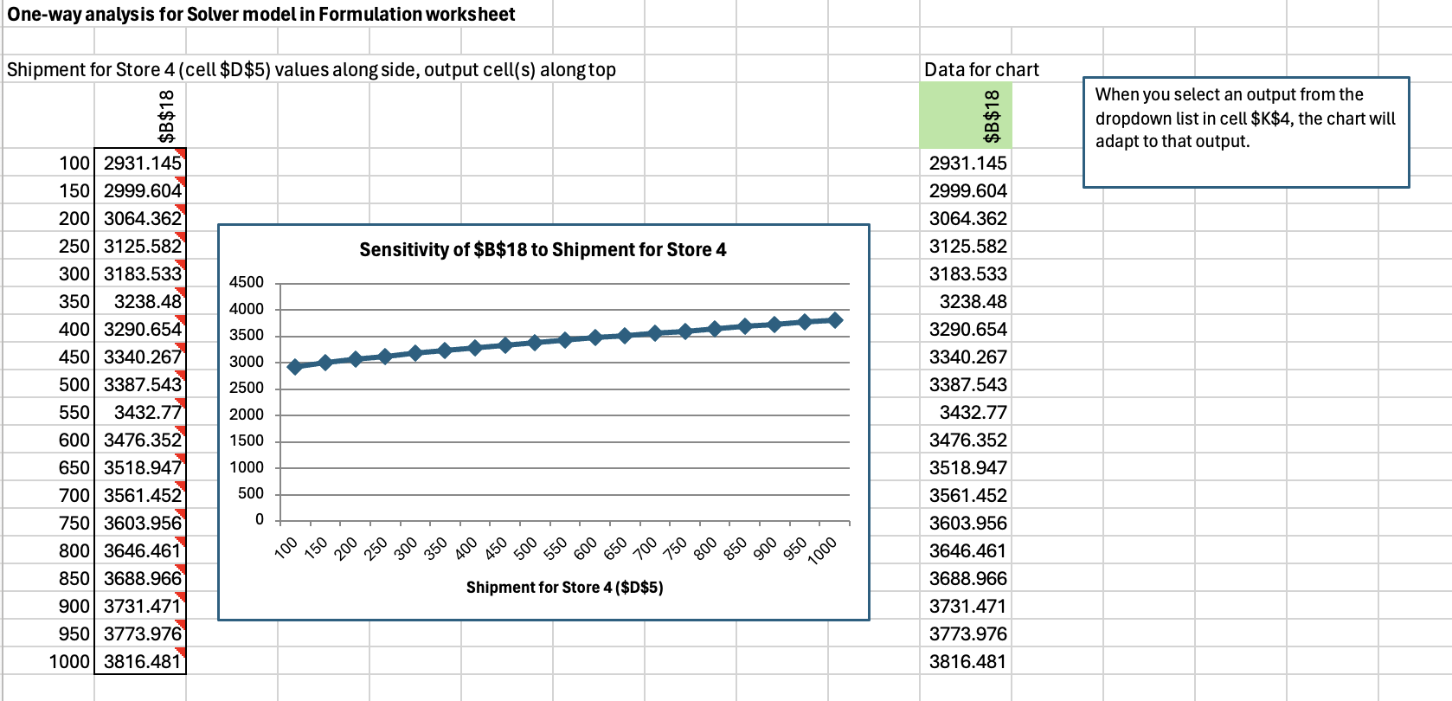

After conducting the one-way sensitivity analysis, focusing on the number of annual shipments for Store 4, we gained valuable insights into how the optimized total distances vary in response to changes in this parameter.

The sensitivity analysis results unveil a clear trend: as the number of annual shipments for Store 4 increases, the optimal total distances from the distribution center to the stores also exhibit an upward trajectory. This observation indicates that higher the shipment volumes for Store 4 higher is the distances traveled within the distribution network.

For instance, as we increment the annual shipment volume by 50 units from 100 to 1,000, we observe a consistent positive correlation with the objective function, indicating an increase in total distances as shipment volumes rise.

To illustrate further, when Store 4 has a relatively modest volume of 100 annual shipments, the optimized total distance amounts to 3,009.70 miles. However, with a substantial increase in the number of annual shipments for Store 4 to 1,000, the corresponding optimal total distance escalates to 3,860.46 miles. Notably, our optimal solution occurs at a shipment volume of 475, with the corresponding total distance being 3,364 miles.

This progressive rise in total distances underscores the significant impact of shipment volume on the overall efficiency of the distribution network. By delving into these relationships, we gain deeper insights into how the delivery system operates, particularly in terms of optimizing the total distances from the distribution center to the stores within McTrump's supply chain.

**Two way sensitivity analysis**

For our two-way sensitivity analysis, we varied the number of annual shipments for Store 2 (with the lowest number of shipments per year) and Store 4 (with the highest number of shipments per year) to see the effect of the change on our objective function, i.e., the minimum total distance from the distribution center to the stores. We have taken a range of 100 to 1,000 with an increment of 50 for both these stores.

**Table 7** displays the two-way sensitivity analysis of the optimal total distances from the distribution center to the stores.

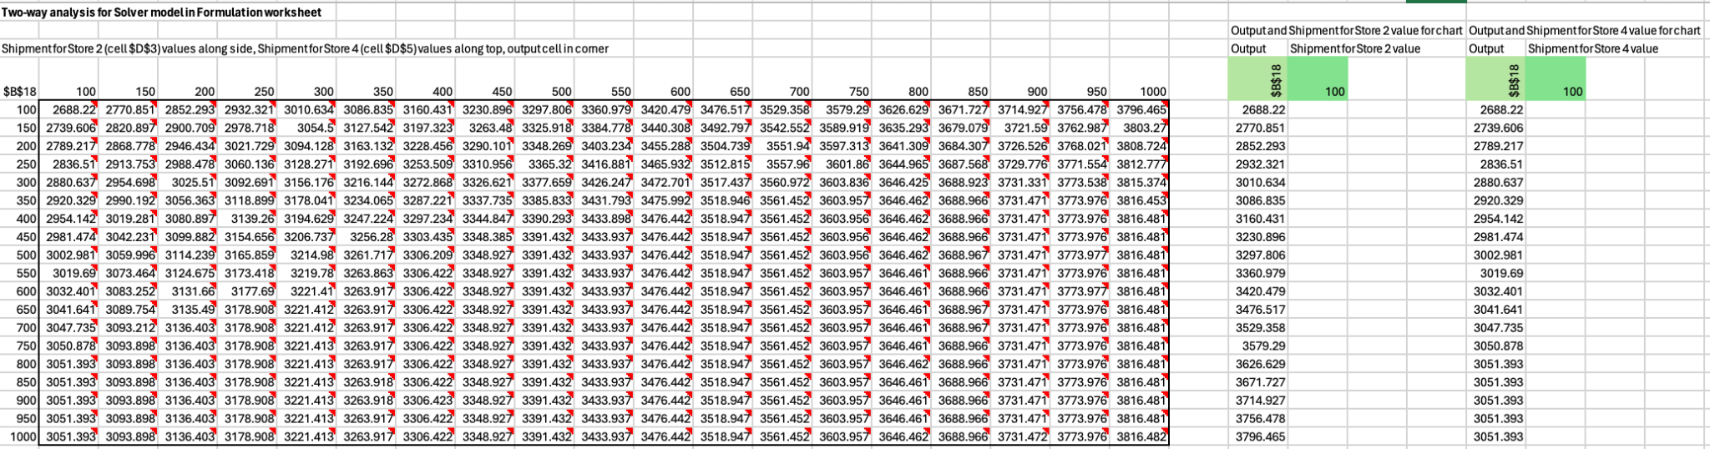

**Figure 7a, 7b, 7c and 7d** depicts the graph which are linear in nature emphasizing a positive correlation

**Figure 7a (at 100 units)**

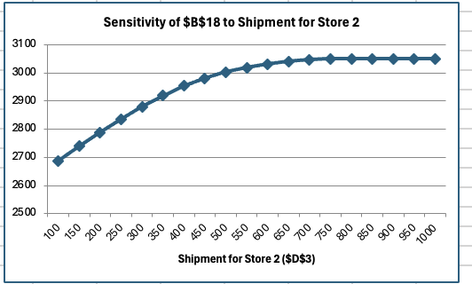

**Figure 7b (at 650 units)**

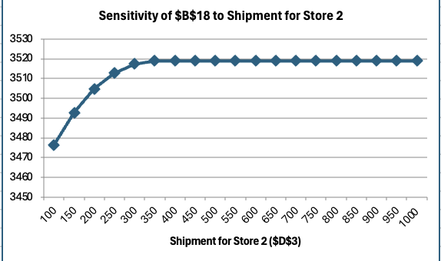

Upon examining the graphs presented in Figure 7a, a clear relationship emerges between the volume of shipments directed towards Store 2 and the corresponding total distance covered in the distribution network.

Firstly, as the number of annual shipments directed towards Store 2 increases, the total distance traveled from the distribution center to all stores shows a noticeable upward trend. This observation indicates that a higher volume of shipments to Store 2 increases the overall distance covered in the distribution network. However, after a point (here at 750 units and above) the objective function is insensitive at about $3050.

From Figure 7b, we can see that the objective function does not change at all (is insensitive) after 350 units and stays at about $3520.

**Figure 7c (at 100 units)**

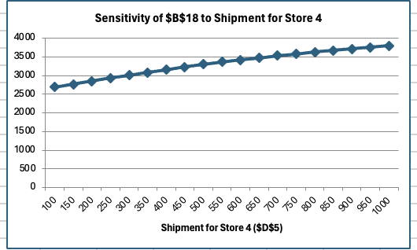

**Figure 7d (at 650 units)**

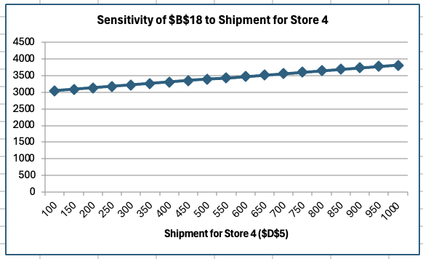

Similarly, from Figure 7c and 7d, we can see that when the volume of shipments directed towards Store 4 is increased, the minimum total distance traveled for deliveries from the distribution center to all stores correspondingly rises. This trend highlights the impact of shipment volume on the efficiency of the distribution network, with higher volumes necessitating longer distances traveled to fulfill deliveries to the designated stores.

However, the strategic insight here lies in the optimal allocation of shipments, particularly towards Store 2. Given its proximity to the distribution center, a more efficient approach involves distributing multiple shipments to Store 2, rather than increasing shipments to Store 4 as it is farther from the distribution center compared to Store 2. This approach minimizes the total distance traveled for deliveries since Store 2 requires less transportation distance.

**Conclusion**

In this project, using Excel Solver and Excel SolverTable add-in, we, as a team, demonstrated the optimal solution for the establishment of a distribution center (DC) to serve McTrump's seven outlets across New York State. The optimization model that we built presents a strategic opportunity to enhance supply chain operations, improve operational efficiency, and drive cost-effectiveness.

Our optimization result shows that the distribution center coordinates, determined through the optimization model, are situated at longitude 40.73148071 and latitude -73.99331366.

**Figure 8** depicts the store locations (blue points) and the suggested location for DC (orange point)

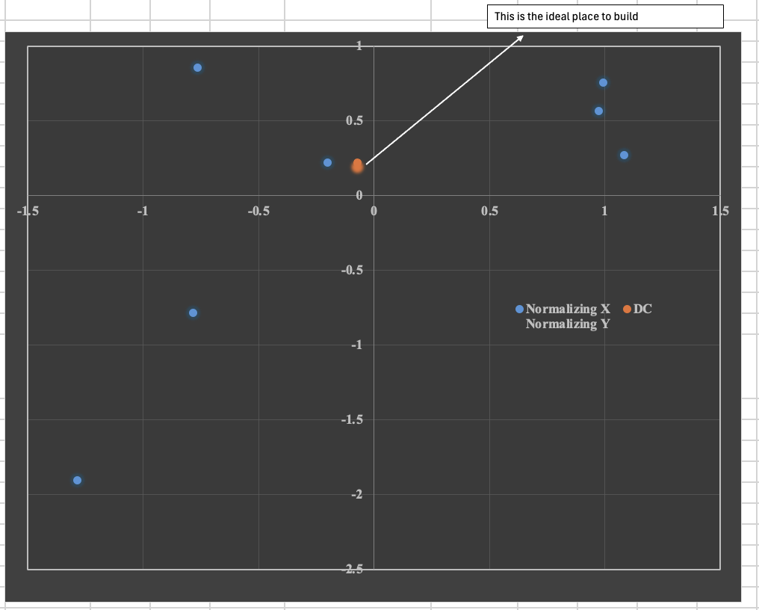

This solution effectively minimizes the total shipping distances from the distribution center to the designated stores, resulting in a total distance of 3,364.18 miles. Implementing this solution across McTrump's distribution network offers significant benefits. By minimizing shipping distances, the company can save on fuel, reduce vehicle maintenance costs, resulting in streamlined logistics operations as well as aids in providing fresh food which results in customer satisfaction.

Furthermore, we also learned additional results by running One-way and Two-way sensitivity analysis using the Excel SolverTable tool. Our prime objective of this study was to see

how the optimal total distance varies with changes in the number of annual shipment parameters of the stores. We observed a direct relationship between the number of annual shipments and the total distance traveled in our distribution network model. As shipment volumes increased, so did the total distances, underscoring the importance of strategic allocation.

**Limitations**

While the optimization model provides valuable insights into McTrump's distribution network, it's important to acknowledge its limitations. Firstly, the accuracy of input data, including store locations, annual shipments, and geographic coordinates, is crucial for the model's effectiveness. Any inaccuracies could compromise the model's effectiveness. Additionally, assumptions made during formulation may not always align perfectly with real-world scenarios, emphasizing the need for ongoing refinement to adapt to changing market conditions and customer demands. These considerations underscore the importance of careful implementation and continuous improvement to ensure the model's efficacy in practical settings.

Moreover, computational complexity may demand significant resources and time, particularly when dealing with large datasets.

**Use cases**

1. **Strategic Utilization of the New Distribution Center**

By strategically focusing on deliveries to stores closer to the new DC, we can achieve a multi-faceted benefit. Reduced transportation costs, faster order fulfillment, and maximized DC utilization all contribute to a more efficient and cost-effective distribution network. This approach ensures a strong return on investment for the new DC and strengthens the overall competitive advantage of the company.

1. **Focus on boosting sales for stores located closest to our distribution center (DC)**

By prioritizing sales for nearby stores, we can create a more competitive advantage by offering faster, potentially more affordable delivery, ultimately enhancing the customer experience and our overall profitability. Thanks to their proximity, we can leverage faster delivery times and potentially lower shipping costs.